|  |
| --- |
| KIT – Informatik-IPD |
| CoCoME Technical Report |
| Dashboard |
|  |
| **Anas Saber 2014** |
| **24.07.2014** |

|  |
| --- |
| This Document describes how the Dashboard of CoCoME work and how it’s implement. The Describe is with the help of Software Diagram of UML. |

Inhalt

1-Introduction 2

2- Architectural Component Model 3

3- Activity Diagram 4

# 1-Introduction

In This Project we use *The Trading System* as it can be observed in a supermarket handling sales. In This Section we discus *FrontEnd* of CoCoME-Project. First able the System implement with help of Web Application in Java and Class-Fish-Server.

The *FrontEnd* used the Model-View-Controller Architect witch with help of JSF (Java Server Faces) realize.

# 2- Architectural Component Model

In This Section, the architecture of *FrontEnd* is described in more detail using UML. The structure of the system divided in 3 Parts. These parts are Use Cases, Connection and BackEnd (see the figure 1).

In the first part Use Cases described in the first version of CoCoME-Documentation.

[URL of CoCoME] <http://www.cocome.org/downloads/documentation/cocome.pdf>.

The Connection part of FrontEnd is divided in two parts one is GET and another is POST. The POST and GET Method are the only to connect to the BackEnd with. The Connection is realized with URL. If the user wants to get/post Information from BackEnd he will get/post the data as CSV and the getting data parser with help of CSVParser Class.

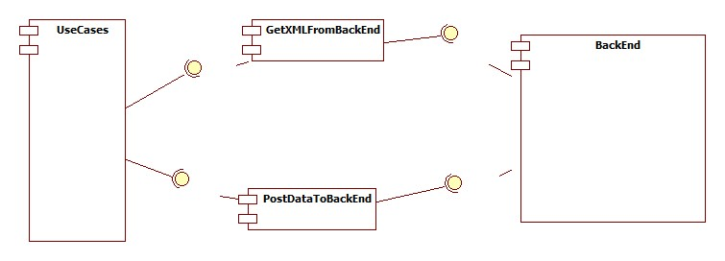

Figure 1: FrontEnd and 3 Components Use Cases, Connection and BackEnd

# 3- Activity Diagram

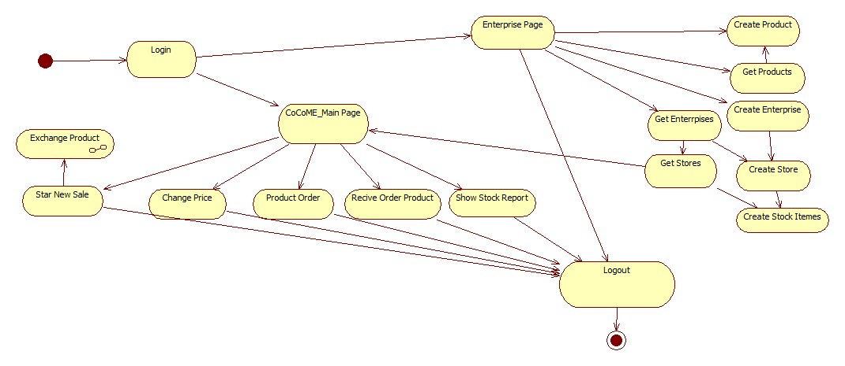

Figure 2: Activity Diagram of the CoCoME BackEnd

In This Section we will know how the Web-App is worked (see figure 2). As user can login the CoCoME-BackEnd as a user with the different roles and in the different pages.

The Roles of user divided as in CoCoME-Documentation described to 4.

1. Cashier
2. Store Manager
3. Enterprise Manager
4. Stock Manager

In each role have a user (Fig. 2 An overview of all considered use cases of the Trading System) some activity to do it. For example the Cashier can only Star a new Sale.

And as an Admin can a user go to Enterprise page or to CoCoME page. In Enterprise Page can a user with role admin get and create Enterprise, Products, Stores and Stock Items. If the user with role admin wants to navigate to CoCoME page he has all roles of all user types.